**KGiSL Institute Of Technology**

**NAAN MUDHALVAN**

***Project Title*** *:*

## Website Traffic Analysis

***Team Members :***

1. Priyadharshini K

2. Salman A

3. Vasanth Kumar V

4. Sahana Lakshmi N

***Problem Definition:***

Analysis of Website Traffic Analysis

***Objectives:***

***Steps:***

IN GOOGLE COLAB NOTEBOOK:

• Mount the GoogleDrive

• Loading the Dataset to GoogleDrive

• Processing and cleansing the dataset

• Accuracy

***Code:***

from google.colab import drive

# This will prompt you to click a link and generate an authentication code drive.mount('/content/gdrive')

***Output:***

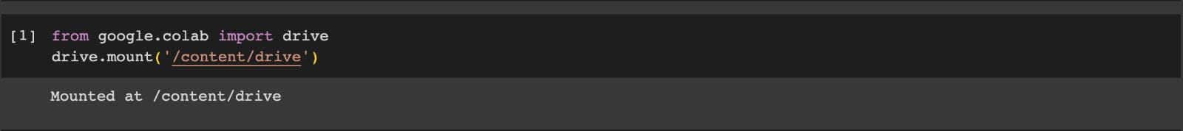

***#LOADING THE DATASET:***

***Code:***

import pandas as pd

# Load your dataset

phase_3 = '/content/gdrive/MyDrive/Colab Notebooks/statsfinal.csv'

data = pd.read_csv(phase_3)

***Output:*** 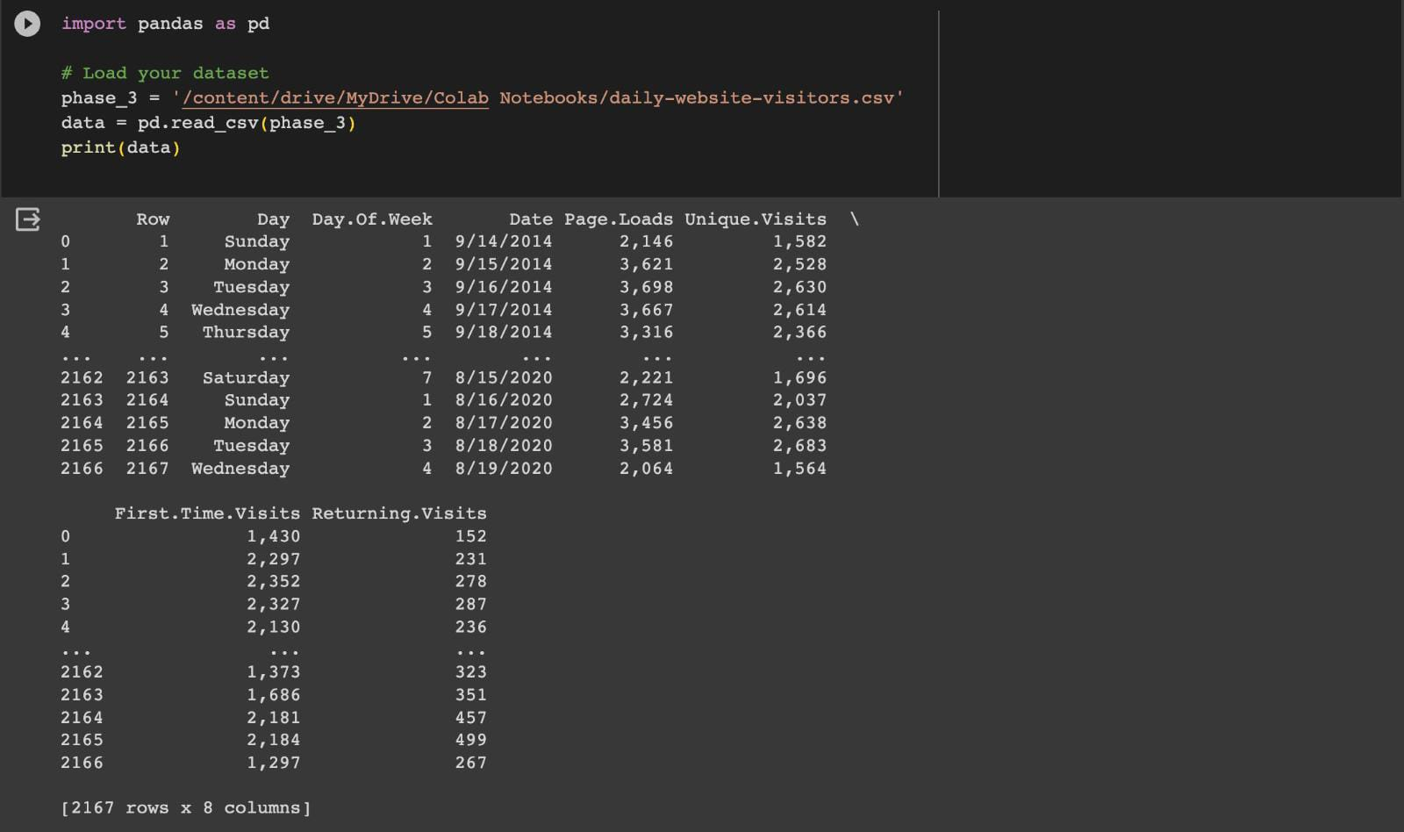

***#PROCESSING AND CLEANSING THE DATASET:***

***Code:***

import pandas as pd

import matplotlib.pyplot as plt

import seaborn as sns

print(data.head()) # Display the first few rows of the dataset

print(data.info()) # Display data types and non-null counts

print(data.describe()) # Summary statistics

***Output:***

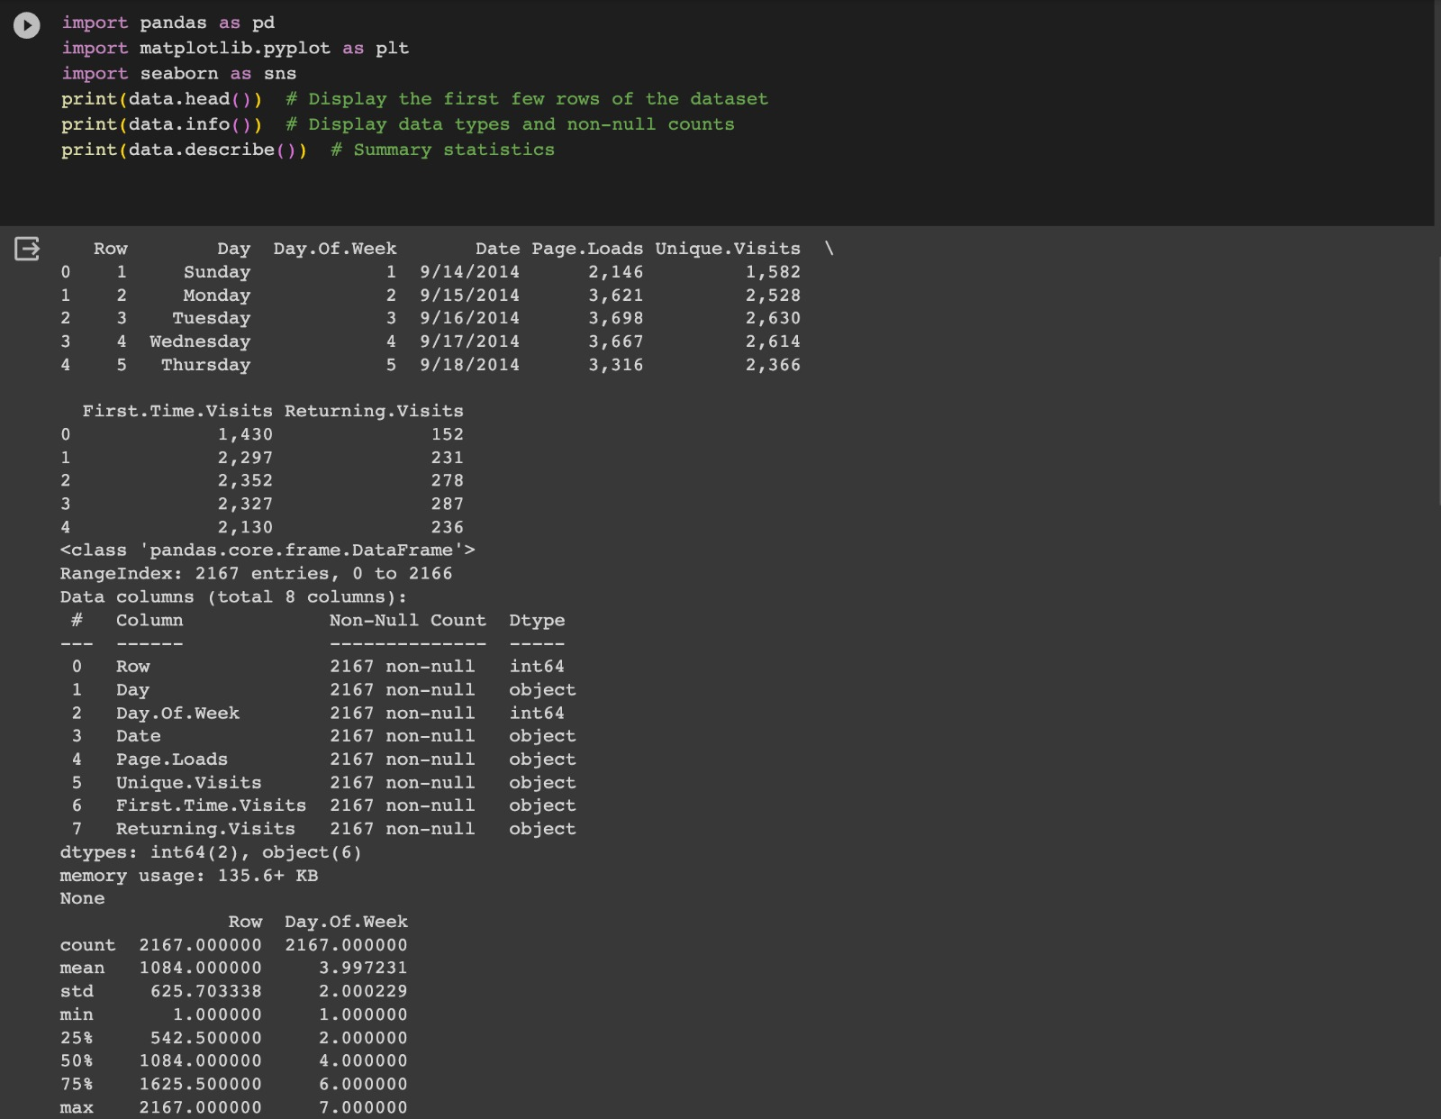

***#CLEANSING THE DATA:***

***Code:***

import pandas as pd

data = data.drop_duplicates()

data.to_csv("cleaned_dataset.csv", index=False)

print(data.describe())

***Output:***

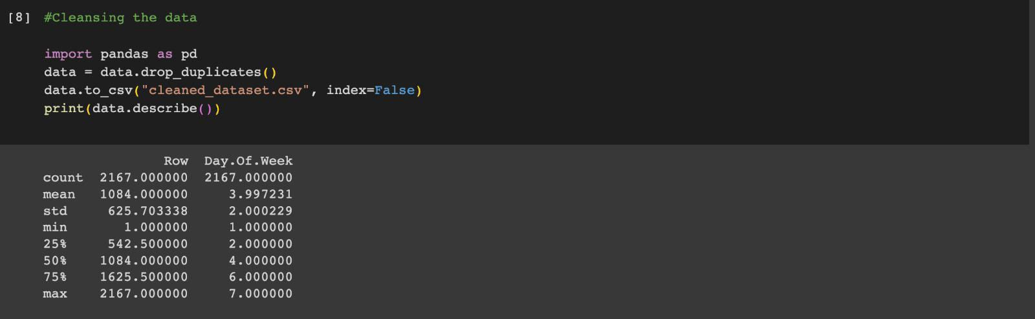

***#ANALYSIS ON DATASET:***

***Code:***

plt.figure(figsize=(10, 6))

sns.barplot(x='Q-P1', y='S-P1', data=data)

plt.title("Sales by Product Category")

plt.xlabel("Product Category")

plt.ylabel("Sales")

plt.xticks(rotation=45)

plt.show()

***Output:***

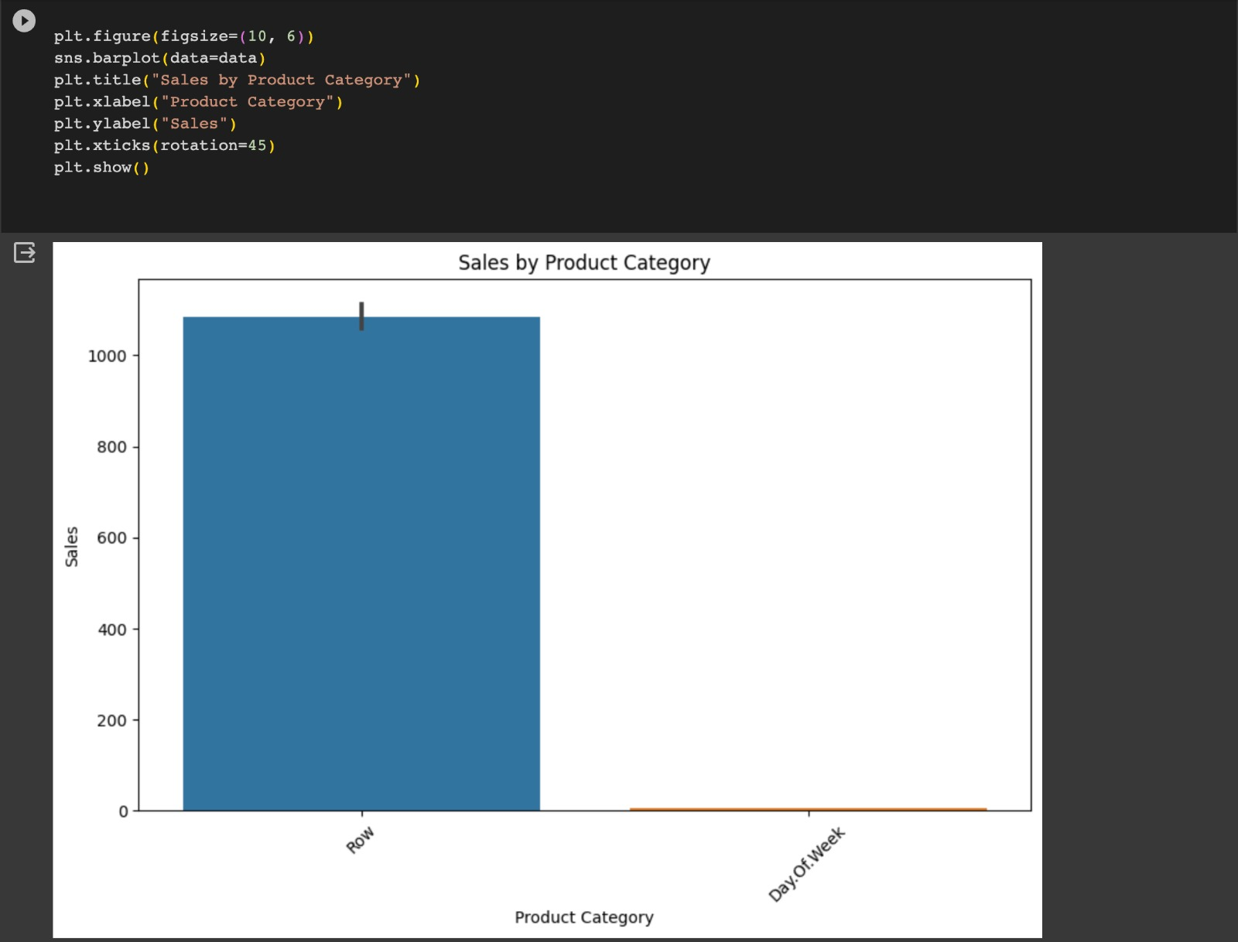

***#LOGICAL REGRESSION:***

***Code:***

from sklearn.datasets import make_classification

from sklearn.model_selection import train_test_split

from sklearn.metrics import accuracy_score

from sklearn.linear_model import LogisticRegression

nb_samples = 1000

x, y = make_classification(n_samples=nb_samples, n_features=2,

n_informative=2, n_redundant=0, n_clusters_per_class=1)

xtrain, xtest, ytrain, ytest = train_test_split(x, y, test_size=0.2, random_state=42)

model = LogisticRegression()

model.fit(xtrain, ytrain)

***Output:***

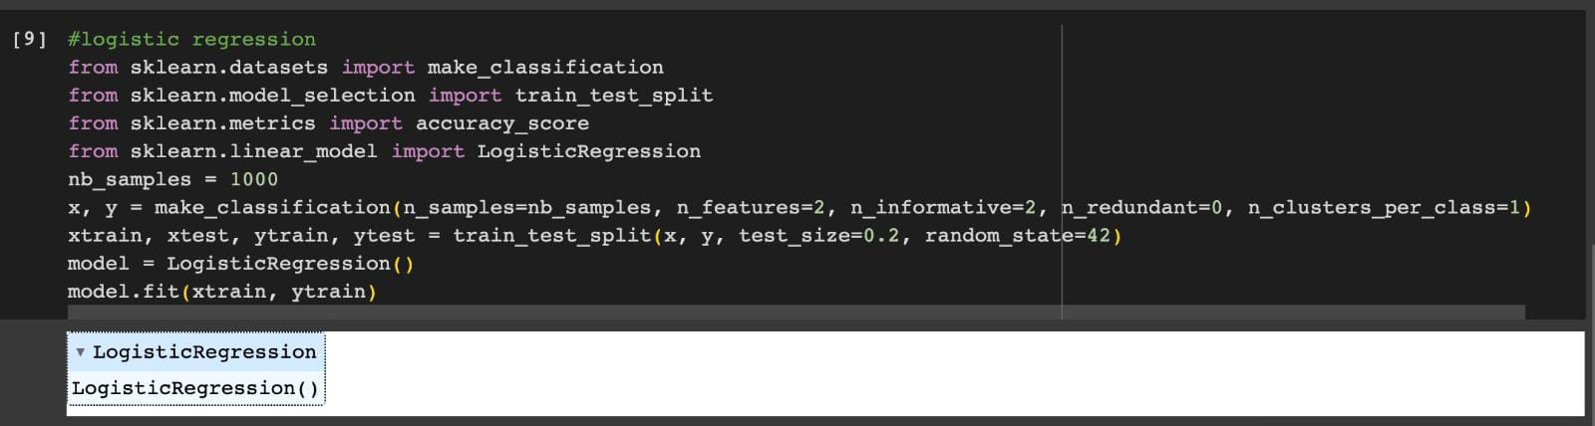

***#ACCURACY:***

***Code:***

print(accuracy_score(ytest, model.predict(xtest)))

***Output:***

